Product Specification File and Inspection Criteria
Section 1 – General Product Details and Description
Section 2 – Product Performance Specification & Critical Component List
Section 3 – Packaging
Section 4 – Labelling
Section 5 – Documentation
Section 6 – Product Finish
Section 7 – Visual Inspection Criteria
Section 8 – Product Test Criteria
Section 9 – fault points should be corrected in the production

The green marked part is original parameter, which shall be replaced by yellow part, the yellow part should be checked by each batch according to IEC standard.

Legend
U₀- Rated no-load voltage
U₁- Rated input voltage
U_{2min}- Min output voltage
U_{2max}- Max output voltage
I₁- Rated input current
I_{2min}- Min welding current
I_{2max}- Max welding current

Product Identification
Vendor Name | HANKER | Cust Product Code |  | Created
Factory Name | HANKER | Cust Product Designation | INMIG 315T | Last Modified
Supplier Item Code | GMAW 315 | Cust Brand | Fubag | Revision | v.1.0
Revision List
Revision Ref | Date of Revision | Description of Revision

Section 1 – General Product Details and Description
General Product Description
Inverter MIG Machine for ARC Welding (MIG/MAG) max 315A, Steel wire feeder, Steel Chassis, 400V/50Hz Input Voltage, power cord 4G2.5 Cu without plug 2m. Power cables inside of the machine 35 mm2 Cu. Rollers into wire feeder should be V-type (for solid wire) 0.8/1.0mm.
Accessories (Packing List) | 1 gas hose, user manual, 1 earth clamp 4m 35mm2 Cu.

Standards
Destination Market | Russia | Destination Market Spec |  | 380V/50 Hz
Criteria | Standard |  | Certificate Number

Product Image

Section 2 – Product Performance Specification & Critical Component List
Product Performance Specification
MIG
Description (400V/50 Hz) | Value & unit  (Ambient temperature) |  | Tolerance | Reference to  GOST EN60974-1-2012
Description (400V/50 Hz) | 20℃* | 40℃ | Tolerance | Reference to  GOST EN60974-1-2012
Power safety device Max Input current (I_{1max}), A | 20A | 20A | ±10%
Max output (I_{2max}), A | 315A | 315A | ±5% | Art. 15.4, c
Min output (I_{2min}), A | 50A | 50A | -10A | Art. 15.4, b
Open Circuit Voltage (NO LOAD Voltage), V | 70V | 70V | +/-5% | Art. 15.4, a
Voltage at max current, V | 30V | 30V | +2,5-1,0V | Art. 15.4, c
Voltage at min current, V | 16.5V | 16.5V | +0,5-2.5V | Art. 15.4, b
Thermostat activation time, load 315A | ≥4’0” | ≥4’0” | -- | --
Welding current at Duty Cycle 100%, А | 200A | 200A | +5%-2%) | Art. 7.1.2
Duty Cycle at maximum current | 40% | 40% | -- | --

MMA
Description (400V/50 Hz) | Value & unit  (Ambient temperature) |  | Tolerance | Reference to  GOST EN60974-1-2012
Description (400V/50 Hz) | 20℃* | 40℃ | Tolerance | Reference to  GOST EN60974-1-2012
Power safety device Max Input current (I_{1max}), A | 24A | 24A | ±10%
Max output (I_{2max}), A | 315A | 315A | ±5% | Art. 15.4, c
Min output (I_{2min}), A | 10A | 10A | -10A | Art. 15.4, b
Open Circuit Voltage (NO LOAD Voltage), V | 70V | 70V | +/-5% | Art. 15.4, a
Voltage at max current, V | 32.6V | 32.6V | +2,5-1,0V | Art. 15.4, c
Voltage at min current, V | 20.4V | 20.4V | +0,5-2.5V | Art. 15.4, b
Thermostat activation time, load 315A | ≥3’30” | ≥3’30” | -- | --
Welding current at Duty Cycle 100%, А | 200A | 200A | +5%-2%) | Art. 7.1.2
Duty Cycle at maximum current | 35% | 35% | -- | --

Specification
 | Description |  | Control level (classification)
 | Test marks: | N/A | Major
 | Certification | CE / GS / UL / CSA/ ETL | Major
 | EC directives | MD / EMC / LVD Emission / NOISE / PAH / ROHS | Major
 | Marking of Electrical and electronic equipment in according with Article 11(2) of Directive 2002/96/EC (WEEE); German version EN 50419: 2004 EN 50419: 2004  2002/96/EC (WEEE)， 11(2) | N/A  According to IEC/EN 60974 | Major
Accessories characteristics
Description | Spec | Control level (classification)
Earth Clamp, cable length 4m, 35mm2, Cu | 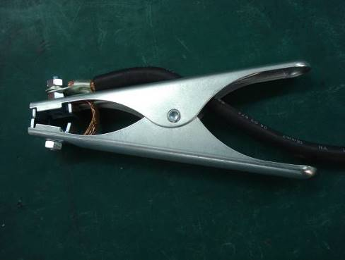 | Major
Gas Hose 3m | 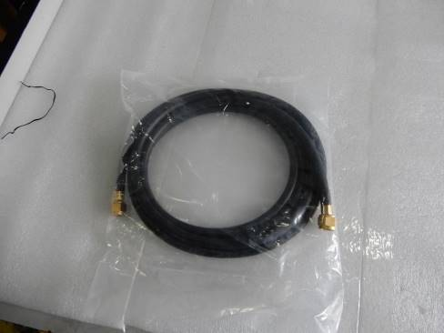 | Major

Power cord
 | Description | Spec | Control level (classification)
 | Length | Cord length 1.9…2.0m | Major
 | Type | H05VV-F 4G2.5mm2 | Major
 | Plug | No plug. End of wire should be soldering or press nozzle.  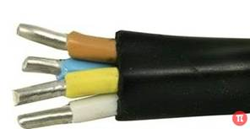 | Critical

Packaging
 | Description | Spec | Control level (classification)
 | Thickness (mm) | TBA | Major
 | Tile | Double-wall corrugate | Major
 | Surface treatment | TBA | Major
 | Connector type | Split top box | Major
 | Inlay material | Polyfoam 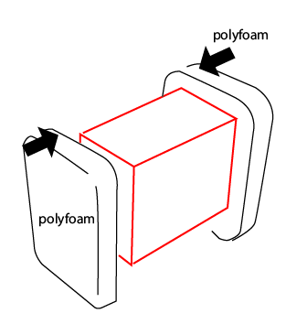 | Major
 | Accessories package | No | Major
 | Quantity | 1 | Major
 | Packing Strap | no | Major
 | Bar code | yes | Major
Critical Component List
Item No. as per Parts List | Code | Description | QTY | Results
1 | 7.2530.007 | handle | 1
2 | 7.0510.1540-FA | Right panel | 1
3 | 6.6860.100 | hinge | 2
4 | 6.6860.001 | Locker | 2
5 | 6.2530.002 | Gas valve | 1
6 | 7.3030.1540-FA | Assembly sheet | 1
7 | 7.1220.1540-FA | fixing plate for fan | 1
8 | 7.0680.1540-FA-A | rear panel | 1
9 | 7.4620.007 | Gas fitting | 1
10 | 6.1550.003 | fixing clamp for power cable | 1
11 | 6.2050.005 | small-sized circuit breaker | 1
12 | 7.3040.003 | switch protection cover | 1
13 | 6.7200.005 | fan | 1
14 | 7.1990.004 | Spool holder | 1
15 | 7.0550.1540-FA-A | bottom plate | 1
16 | 3.0628.3006 | 3 phase power PCB | 1
17 | 3.P628.1012 | Control PCB | 1
18 | 7.3040.004 | double drive Wire feeder cover | 1
19 | 6.7100.101-A | double drive Wire feeder device | 1
20 | 7.1230.904 | double drive Wire feeder bottom plate | 1
21 | 5.1850.1540 | main transformer | 1
22 | 5.2710.1566 | inductance | 1
23 | 7.1230.156 | plastic holder for transformer | 1
24 | 6.3050.003 | Shunt | 1
25 | 7.1780.002 | Wire connector | 1
26 | 7.1770.001 | Connector | 1
27 | 7.7130.032 | insulation plate | 1
27 | 7.7130.033 | insulation plate | 1
28 | 6.6670.001 | Central socket | 1
29 | 7.0690.1540-FA | front panel | 1
30 | 7.7130.028 | insulation plate | 2
30 | 7.7130.029 | insulation plate | 2
31 | 6.1520.201 | euro socket (without plastic cover) | 2
32 | 6.2320.203 | On/Off switch | 1
33 | 6.4580.001-R | knob | 1
34 | 6.4580.004-R | knob | 2
35 | 6.2240.300-B1 | nut | 2
36 | 3.0628.4046 | front panel | 1
37 | 7.0500.1540-FA-B | Left panel | 1

Item No. as per Parts List | Code | Description | QTY | Results
А | S.200RM.210 | Плата в сборе
A1 | 7.1230.911 | Assembly sheet | 1
A2 | 7.4230.020 | heat sink for FRD | 1
A3 | 7.4230.019 | heat sink for FRD | 1
A4 | 6.4010.216 | fast recovery diode | 12
A5 | 7.4220.009 | heat sink | 1
A6 | 7.4220.058-A | heat sink | 1
A7 | 6.2310.102 | switch | 1
A8 | 6.4250.011 | IGBT | 8
A9 | 6.4110.009 | 3 phase rectifier bridge | 1
A10 | 6.6620.001 | Insulation part | 1
A11 | 7.7130.001 | insulation plate | 20
A12 | 3.0628.2014-A | 3 phase IGBT drive panel | 1
A13 | 7.4220.059 | heat sink | 1
A14 | 3.0628.6013-A | FRD PCB | 1
A15 | 7.1230.025 | Assembly part | 2

Exploded view

Section 3 – Packaging
Package
Packaging Description
Colour Fubag sticker on Box

Packaged Dimensions, LWH, mm | 760x320x580
Gross Weight/Net Weight | 31/26.0 | Bar code
Pcs per Outer | 1 | Pcs Per Inner | N/A
Outer Carton Material Spec | Color 5-layer carton, thickness min. 5mm | Inner Carton Material Spec | N/A
Shipping Mark & Spec (Font Size Etc)
Poly Bag Spec and Warning Labels

Section 4 – Labelling
Labelling Requirements

Specification and model name

Side silkscreen
GREY - PANTONE 424C
WHITE – NOT DEFINED

Front panel sticker
Section 5 – Documentation
Document List
Document No. | Description
1. | User Manual

Document No. 1 Specification
Doc Name/Desc | User Manual
No of Pages |  | Size | 148*210 (A5) | Description/Style | Leaflet (A5) with full-colour cover and black-white internal block. Language English/Russian
Material/Paper Spec
Artwork/Document Number

Section 6 – Product Finish
Finish Specification
Item Number | Description | Type of finish | Colour Reference
1 | handle | Black Powder Coating + Moulding | Metal, Black RAL9005 + Rubber, Black
2 | Right panel | Red Safety Powder Coating | Metal, RAL3028”
3 | hinge | Black Powder Coating | Metal, Black RAL9005
4 | Locker | Moulding | Plastic, Black
6 | Assembly sheet | No | Silver
8 | rear panel | Black Powder Coating | Metal, Black RAL9005
10 | fixing clamp for power cable | Moulding | Plastic, Black
14 | Spool holder | Moulding | Plastic, Black
15 | bottom plate | Black Powder Coating | Metal, Black RAL9005
18 | Single drive Wire feeder cover | Moulding | Plastic, Black
27 | insulation plate | Moulding | Plastic, Black
29 | front panel | Black Powder Coating | Metal, Black RAL9005
30 | insulation plate | Moulding | Plastic, Black
37 | Left panel | Red Safety Powder Coating | Metal, RAL3028”

Section 7 – Visual Inspection Criteria
Visual Inspection Random Sampling Plan: -
General Inspection Level II – Use IAOC AQL table to establish sample size.
Acceptable Quality Levels as per criteria below.
DESCRIPTIONS | CRI.  AQL  0.0 | MAJ.  AQL  1.5 | MIN.  AQL  2.5
Appearance
Burr / sharp point / sharp edge/ hazardous finger entrapment  Injures consumer  Causes potential injury to consumer | * | *
Non-compliance in dimension, colour, shape, material |  | *
Marred / gritty / discoloured surface / scratch marks |  | *
Rust / bare spots on hardware |  | *
Plastic flash |  | *
Chips / cracks / poor painting or coating |  | *
Scratch marks  Obvious to eye  Not obvious to eye |  | * | *
Mill marks/ burn marks/blister/scars in castings |  | *
Check for dents on steel panels |  | *
Poor appearance of Welding |  |  | *
Construction
Exposure of any live wires or parts | *
Non-compliance with standards | *
Component missing / malformed / fractured |  | *
Non-compliance in component |  | *
Incorrect length/size of wires/cords |  | *
Improper Component |  | *
Incorrect length/size of earth clamp/torch |  | *
Unsecured fastening where rigidity is required |  | *
Incorrect length of wire polarity switching |  | *
Package
Illegible silk screen printing or incorrect ratings | *
Absence of serial number/poor quality of serial number marking/  illegible serial number | *
Non- compliance in labelling on the welding machine (front, side and back panels) with the layout assigned |  | *
Non- compliance in material of chassis, back panel and front frame |  | *
Non-compliance in accessories |  | *
Non-compliance in assembly | *
Missing Instruction Manual in Russian language |  | *
Moisture / water damage to colour box / master carton |  | *

Section 8 – Product Test Criteria
Product Test Random Sampling Plan: -
Inspection Level S3 – Use IAOC AQL table to establish sample size.
Acceptable Quality Levels as per criteria below.
DESCRIPTIONS | METHOD | CRI.  AQL  0.0 | MAJ.  AQL  1.5 | MIN.  AQL  2.5
Ease of assembly test | S-3  Assemble with tools per instruction provided |  | *
Dimension measurement test | S-3  Verify all dimensions against the line drawing / product specification |  | *
Function and Performance test | S-3  Verify all functions against the product specification on stand (at MIG/MAG, modes) – max current, min current, off load idle run, max load idle run  S-3  Perform the welding at max welding current with electrodes of a max allowed diameter till the thermal relay switches off the machine. The activation time should be not less than indicated in the specification (ambient temperature 20° C, humidity 75%). Record the activation time.  S-3  In true temperature, perform the welding for 10 minutes at max welding current with electrodes of a max allowed diameter till the thermal relay switches off the machine. The activation time should be not less than indicated in the specification. Record the activation time.  If the ambient temperature is low, the thermal relay may not work. Then place the machine into 40° C to test rated duty cycle till thermal relay switches off machine. Record the activation time. |  | *  *  *
Easy start function | S-3  For easy start function need check pre-start wire speed. Should be 6m/min. |  | *
Connection all cable | S-3  Check all connections. Should be good fixing, without any defects. |  | *
Check programming of control panel | S-3  All function for control should be according to the manuals. |  | *
Data on the roller | S-3  Check data of wire diameter on the each side of roller. Should be according to the real diameter of wire. |  | *
Check gas connector | S-3  Should be ¼” |  | *
On/Off test | All samples  Actual use |  | *
Check color | The measurement of the color in order to value the correspondence to the standard will be produced with the help of the color reader Konica CR-10. Red color RAL 3028 is considered to be a standard color with a deviation registered pursuant to the color reader not more than 3.7.  The measurement of the gloss level in order to value the correspondence to the standard will be produced with the help of the gloss tester KSJ MG621.  The gloss level within 70-80% is considered to be a standard.  The standards produced in the correspondence to the described above requirements should be performed in two samples: one being kept at the Buyer’s office and the other being kept at the factory.  The described above samples are considered to be the final etalon. The testing of the color and gloss level of all the products should be performed in the correspondence to this very etalon. | *

DROP TEST
Impact Carton Drop Test For Full Packing | Drop 3 Master Cartons from 250mm (+10-0mm) as EN60974-1-2014 art 14.4. If: | No broken, cracked or deformed parts or components.

MIG
Serial number | Power safety device Max Input current (I1max), A | Open Circuit Voltage (NO LOAD Voltage), V | Min output (I2min), A | Voltage at min current, V | Max output (I2max), A | Voltage at max current, V | Duty Cycle, %  40°C | Duty Cycle, %  20°C
Serial number | 20±10% | 70±5% | 50±10A | 16.5+0,5-2.5V | 315±5% | 30+2,5-1,0V | ≥40 | ≥40
MMA
Serial number | Power safety device Max Input current (I1max), A | Open Circuit Voltage (NO LOAD Voltage), V | Min output (I2min), A | Voltage at min current, V | Max output (I2max), A | Voltage at max current, V | Duty Cycle, %  40°C | Duty Cycle, %  20°C
Serial number | 24±10% | 70±5% | 10±10A | 20,4+0,5-2.5V | 315±5% | 32.6+2,5-1,0V | ≥35 | ≥35

